Next steps in Gen AI Academy APAC Edition

Thanks for registering for Gen AI Academy APAC Edition! Here’s what to do next:

Follow the steps below to complete your journey after registration.

1. Create a Google Skills Account
To start your learning journey and complete Google Skills Labs, you'll need to create a Google Skills account. This account is mandatory to get access to hands-on training content and tracking your progress throughout the program.

Follow the steps below to quickly set up your account and get started.

- Visit https://www.skills.google/
- Click on Join in (upper right corner).
- Make sure you are using the same email address used for registering in the Gen AI Academy APAC Edition Program
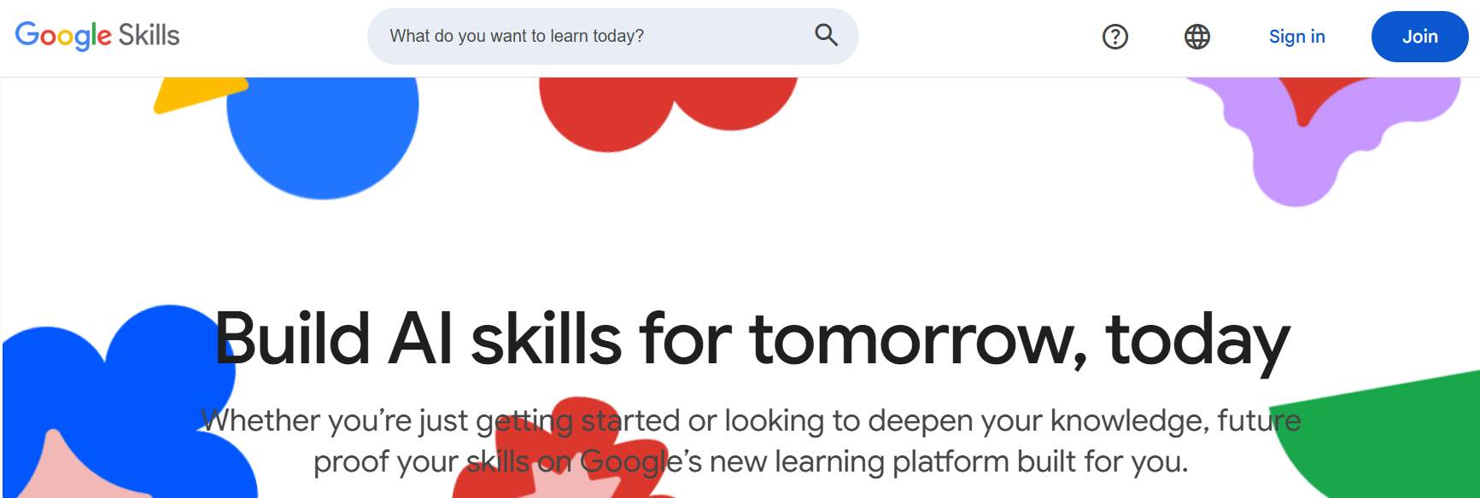

- Enter the required details.
- Make sure you use your gmail account and not company domain
- Click on create account
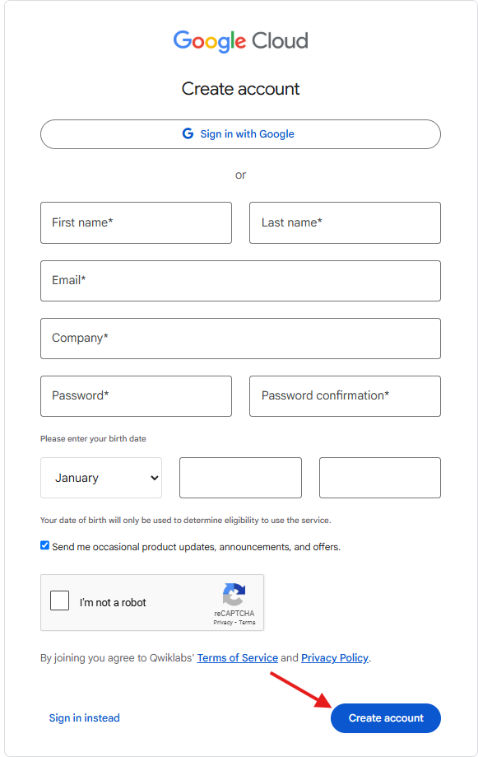

2. Make Your Profile Public
Once you’ve created your Google Skills, the next important step is to make your profile public. Follow the simple steps below to make your profile public and get the shareable link for submission

- Click on your profile icon (upper right corner)
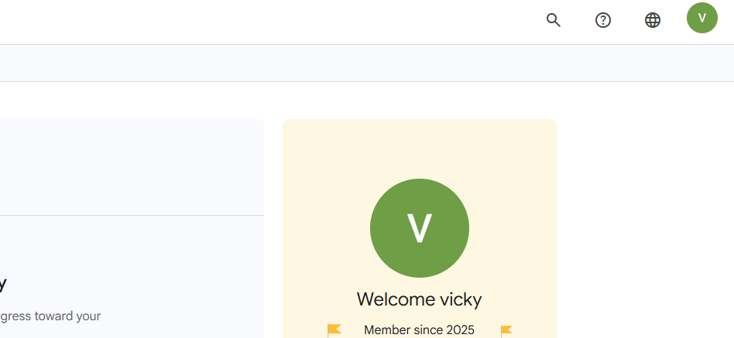
- Go to settings and scroll down
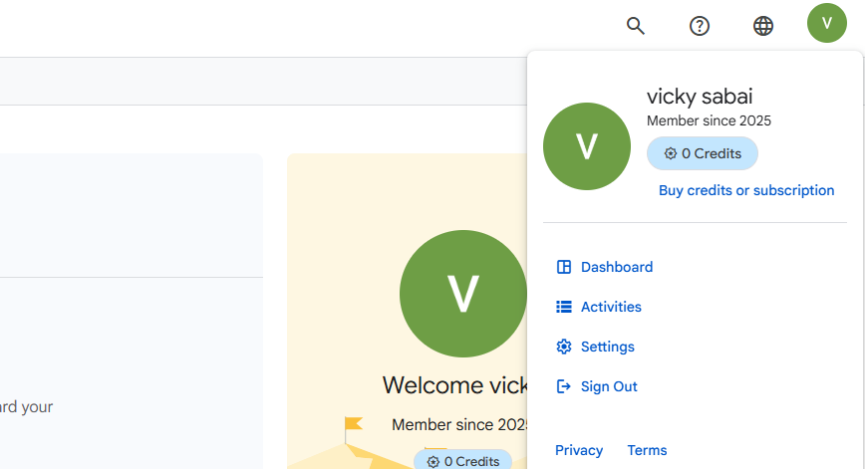
- Under Public Profile header
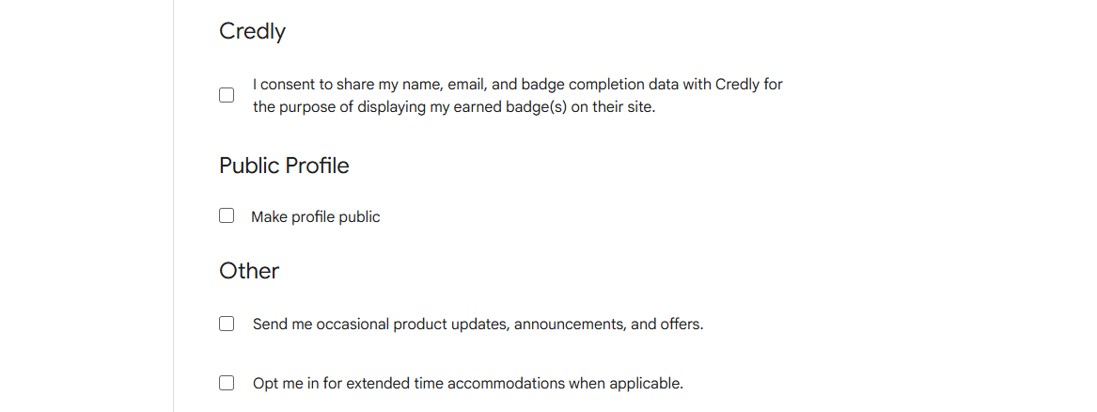

- Click on the Check the Box and Click “Update Settings”
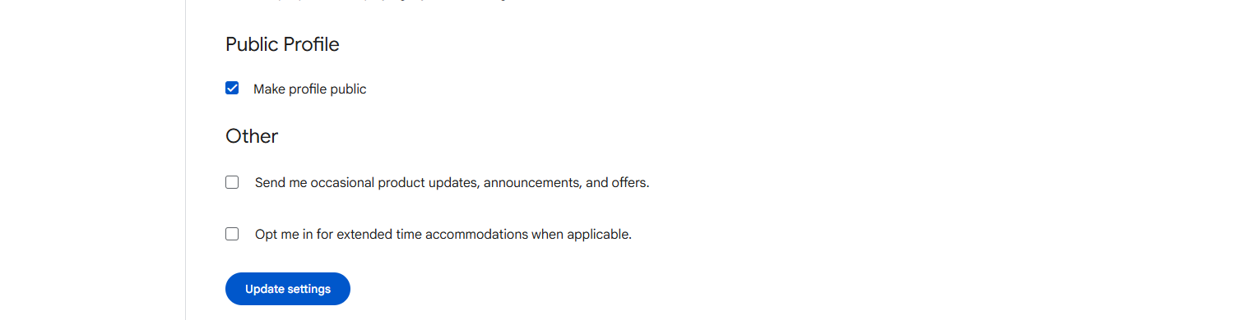

- Once done your profile will be public and you will see the link for your public profile under the Public Profile
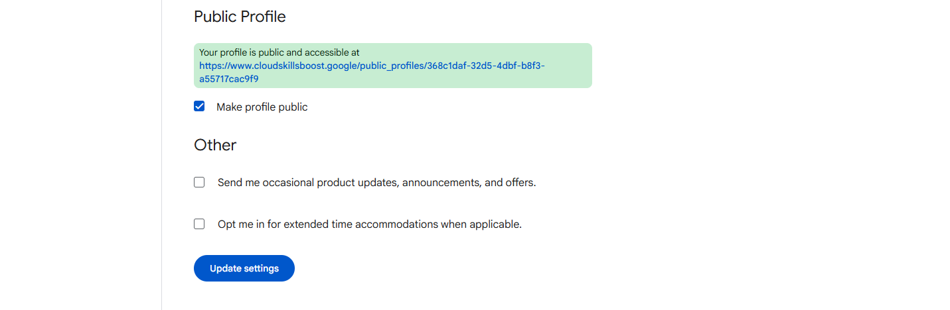

- Copy the public link
- On the hackathon dashboard, click on Forms tab
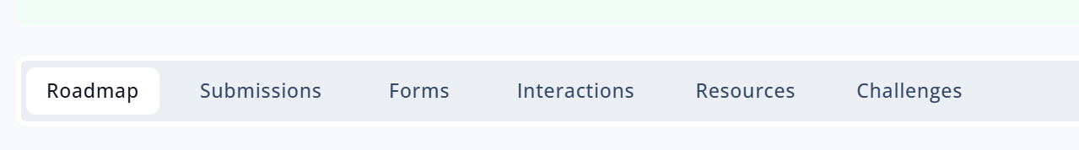

- In the Google Skills Profile Submission section, you will see “Share your Google Skills public profile link” form, open it and enter the details
- Please enter the same email address used for hackathon registration and for creating your Google Skills profile
- Also paste the Public Profile Link which is copied from the Google Skills platform
- Once done, Click on Submit
